**RIPHAH INTERNATIONAL UNIVERSITY ISLAMABAD**



**Bachelor of Computer Science – 5th Semester**

**OS Lab-3**

**Submitted to: MS. Kasusar**

**Submitted by: Faareha Raza Qadri**

**Sap ID: 47431**

**Lab Task**

**Q1.** Make the following directory (03 Marks)

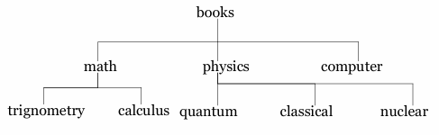

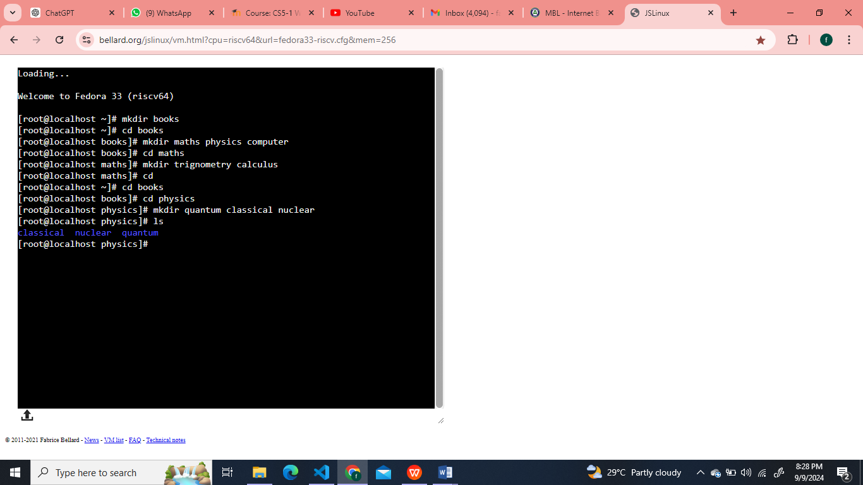

**Q2.** Which are the Linux Directory Commands? Explain the understanding of commands in your own words. Also define what is BASH? (02 Marks)

**Note:** Include screenshots, where required to illustrate your explanation.

1. **ls:** Lists files and directories in the current directory.
2. **cd:** Changes the current directory.
3. **mkdir:** Creates a new directory.
4. **rmdir:** Removes an empty directory.
5. **rm:** Removes files or directories
6. **pwd:** Prints the current working directory.
7. **cp:** Copies files or directories.
8. **mv:** Moves files or directories.

**What is BASH?**

BASH (Bourne Again SHell) is like an interpreter between you and your computer. This is where you can type commands and tell your computer what to do.

**Why is BASH important?** BASH is like the brains behind the terminal in Linux. It understands your instructions and executes programs or manages files. It’s more efficient and faster than clicking through menus, especially if you want to automate things.

**In simple terms:**

Think of BASH as talking directly to your computer. Instead of using a mouse to click on icons, you just type commands.

**Q3.** 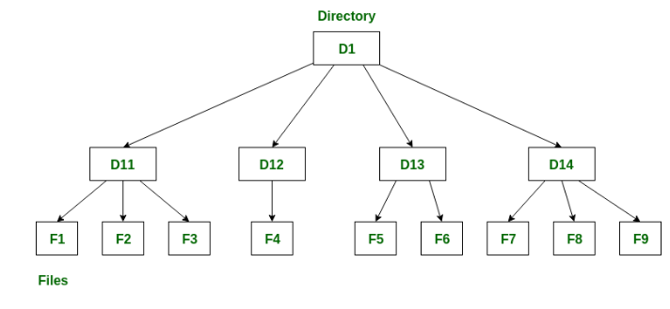

**Note:** Include screenshots, where required to illustrate your explanation. (02 Marks)

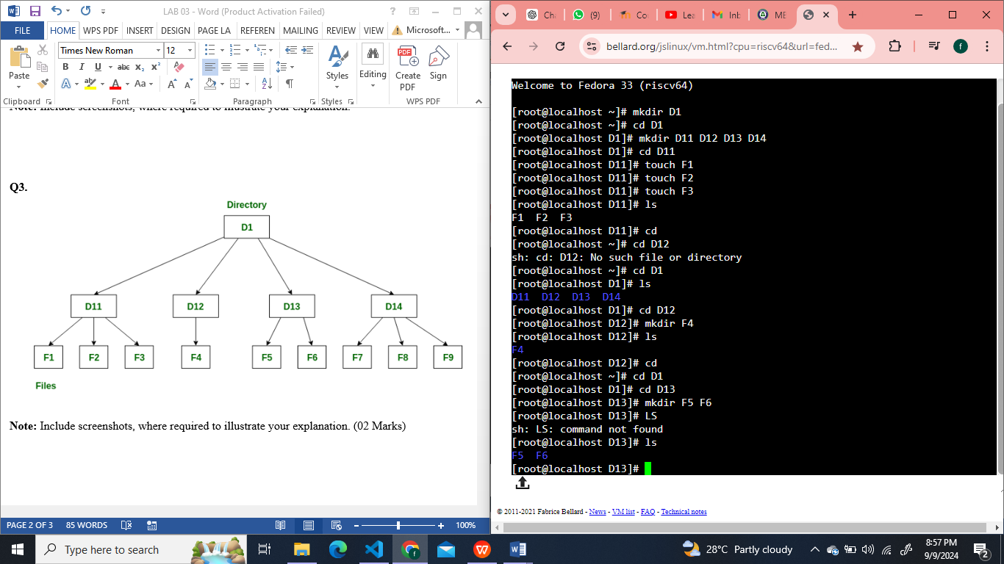

**Q4.** Make the following directory (03 Marks)

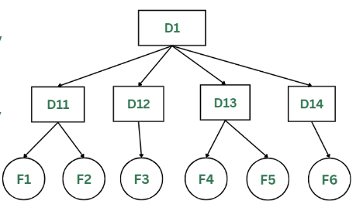

**Note:** Include screenshots, where required to illustrate your explanation.

